**DAILY ONLINE ACTIVITIES SUMMARY**

|  |  |  |  |  |
| --- | --- | --- | --- | --- |
| **Date:** | 20/05/2020 | **Name:** | | Krishnitha |
| **Sem & Sec** | IV sem, A section | **USN:** | | 4AL18CS039 |
| **Online Test Summary** | | | | |
| **Subject** | OOC | | | |
| **Max. Marks** | 30 | | **Score** | 20 |
| **Certification Course Summary** | | | | |
| **Course** | STEPathon-communication skills [ICT ACEDAMY] | | | |
| **Certificate Provider** | THE HINDU | | **Duration** | 3hrs |
| **Coding Challenges** | | | | |
| **Problem Statement:** 1) Given an array a[ ] of size n which contains elements from 0 to n-1, write a program print Duplicates which prints the duplicate elements of the given array. If no duplicate element is found print -1. **2)** Write a C Program to Reverse a Linked List (SLL) in groups of given size. | | | | |
| **Status:** Executed | | | | |
| **Uploaded the report in Github** | | | yes | |
| **If yes Repository name** | | | <https://github.com/krishnitha/lockdown-coding/blob/master/duplicate.java>  <https://github.com/krishnitha/lockdown-coding/blob/master/reverse.c> | |
| **Uploaded the report in slack** | | | yes | |

Online Test Details:

Today we had assessment in the subject OBJECT ORIENTED CONCEPTS. It was based on first module of this subject. There were total 30 number of questions of 1 mark each.

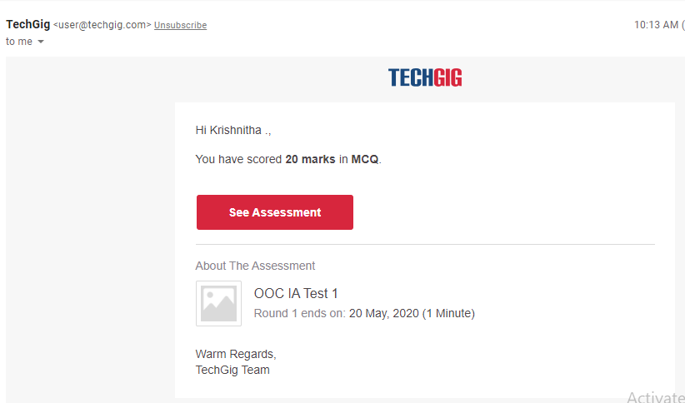

Certification Course Details:

Today I have done STEPathon-communication skills certification course. This course is on communication skills. Today I have completed the week 1 and 2 of the course consisting of 14 videos. There were assessment’s related to our listening, Reading, Writing and Grammar skills.

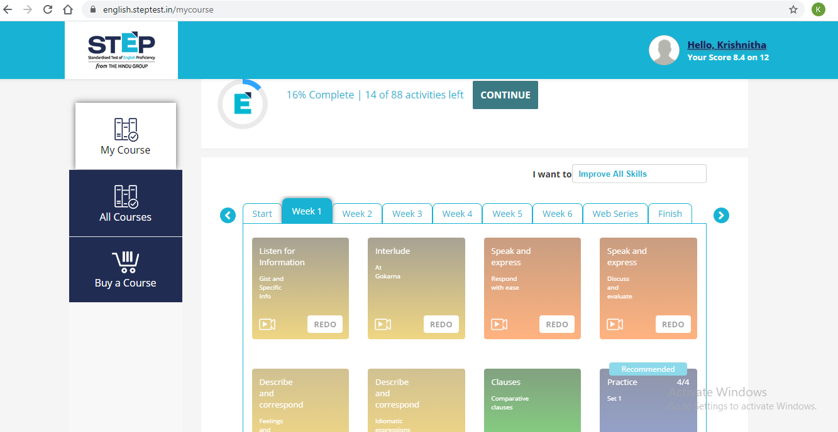

## 

Coding Challenges Details:

Problem 1: Given an array a[ ] of size n which contains elements from 0 to n-1, write a program print Duplicates which prints the duplicate elements of the given array. If no duplicate element is found print -1.  
Input:  
The first line of input must contains an integer n which denotes number of elements of Array. Second line contains n space separated integers denoting elements of array a[ ].

**Output:** Print the duplicate elements from the given array.

Solution: Uploaded in GitHub.

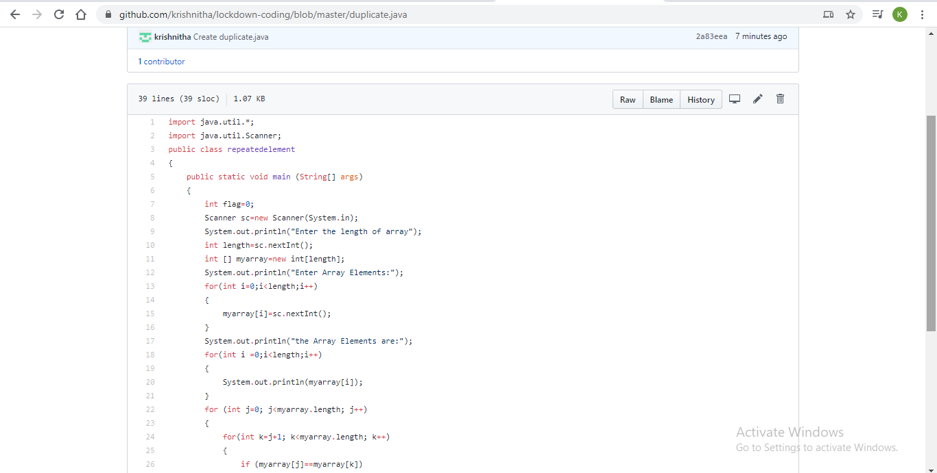

Problem 2:  Write a C Program to Reverse a Linked List (SLL) in groups of given size.

Test Case 1:  
If a linked list is: 1 → 2 → 3 → 4 → 5 → 6 → 7 → 8  
The value of size k is 2  
Then the linked list looks like: 2 → 1 → 4 → 3 → 6 → 5 → 8 → 7

Test Case 2:  
If a linked list is: 1 → 2 → 3 → 4 → 5 → 6 → 7 → 8  
The value of size k is 3  
Then the linked list looks like: 3 → 2 → 1 → 6 → 5 → 4 → 8 → 7

Solution: Uploaded in GitHub.

